**[Research on U.S. Citizen Innovativeness]**

**Project preproposal**

**Principal Investigators: Zheng Su, Yanni Zhang (zsu78@wisc.edu)**

**Questions to be addressed**

In covid-19, economies have been hit to different degrees, and economic growth has slowed down. To move away from dependence on government emergency bailouts and protect against global risks, it is vital to study the factors that affect science and technology innovation. Our research wanted to discover the key factors that determine what makes an individual an innovator. After a preliminary review of the relevant literature, we believe factors that may influence citizens' ability to innovate include birthplace, gender, race, and socioeconomic status. We intend to apply the data to verify these variables. Also, since the dataset contains children who have total patent citations in the top 5% of their birth cohort, we can use parallel studies to see if the factors influencing the emergence of leading innovators and general innovators are the same.

**Data**

Our data are from the dataset of *Who Becomes an Inventor in America? The Importance of Exposure to Innovation* in Opportunity Insights(<https://opportunityinsights.org/data/>). Most of the data are for percentages in specific populations, so there are no units. The dataset covers patenting outcomes for children born in 1980-1984 by the state where they grew up, gender, and parent income. Important data include the share of innovators by state and by category, gender, etc. One shortcoming of the data is that innovators are a tiny percentage of the total, resulting in each percentage being too small to read the data visually. One way to solve this is to translate the data into the number of innovators in 10,000 people.

**Proof of concept**

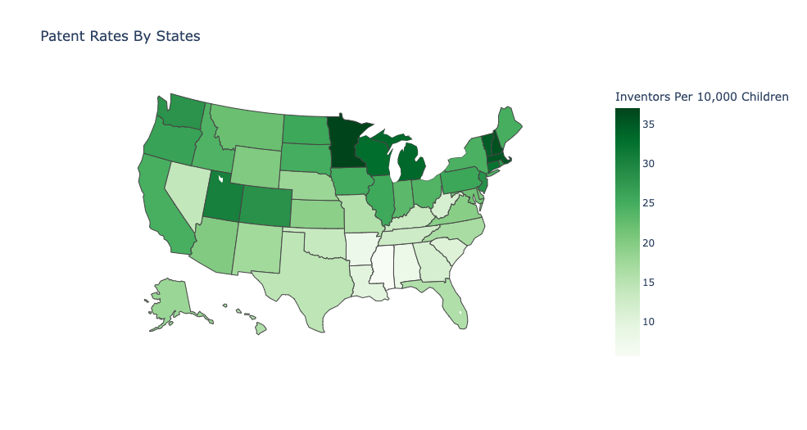

A child is defined as an inventor if he or she was included in a patent application between 2001 and 2012 or was granted a patent between 1996 and 2014. Darker colors denote areas where more children grow up to become inventors. As the figure shows, the number of children growing up to be innovators varies between states in the United States, so there is heterogeneity that can research.